1.
USE AdventureWorks2019
GO
SELECT * FROM HumanResources.Employee
ORDER BY JobTitle ASC
Output:
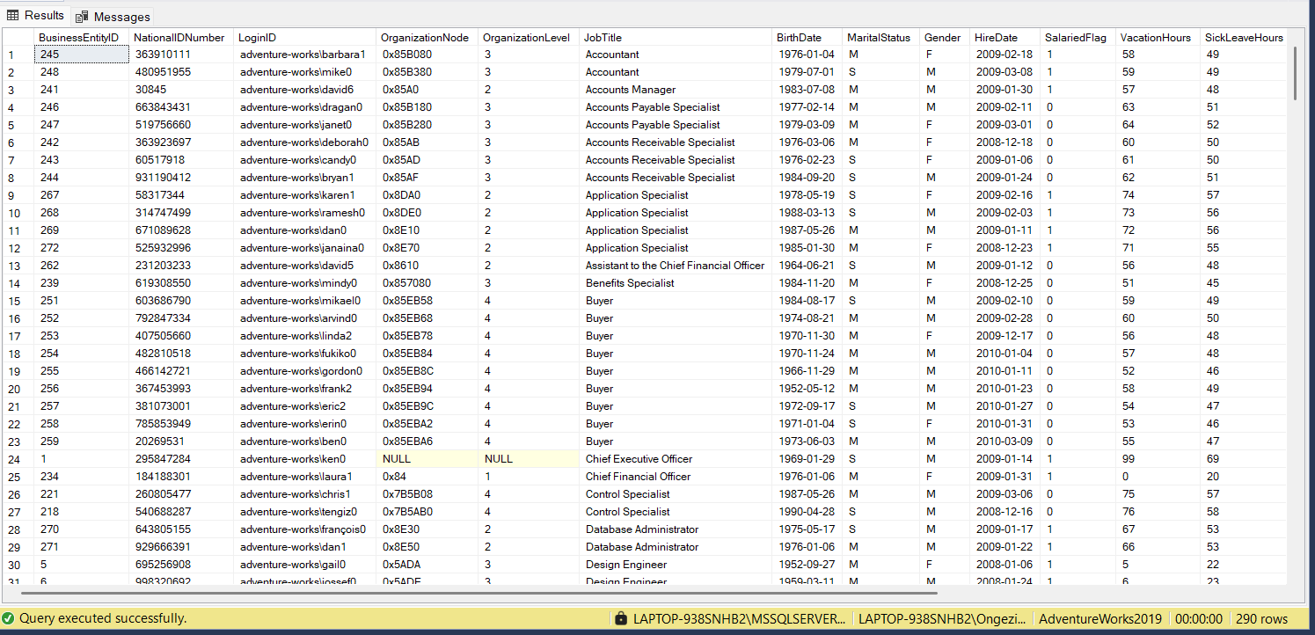
2.
USE AdventureWorks2019
GO
SELECT p.* FROM Person.Person as p
ORDER BY p.LastName
Output:
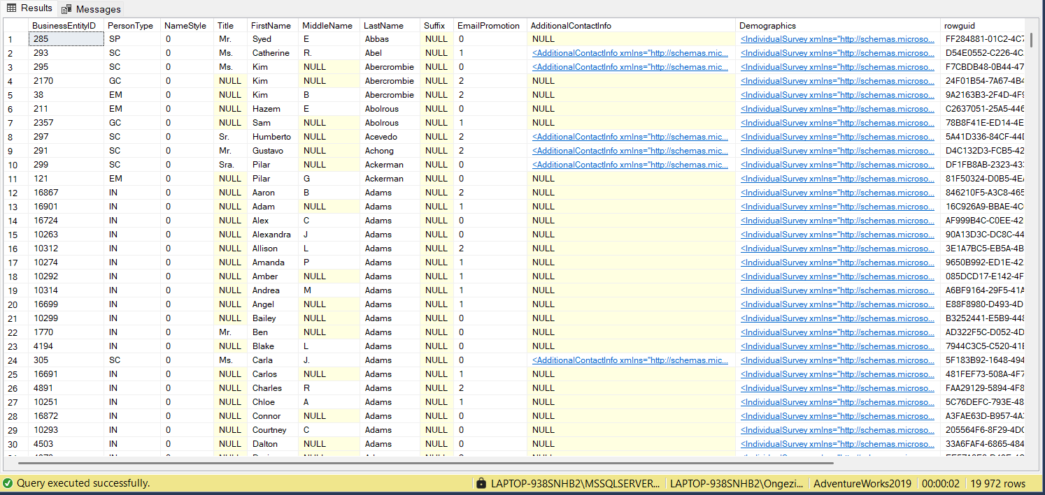
3.
USE AdventureWorks2019
GO
SELECT FirstName, LastName, BusinessEntityID AS Employee_id FROM Person.Person
ORDER BY LastName ASC
Output:
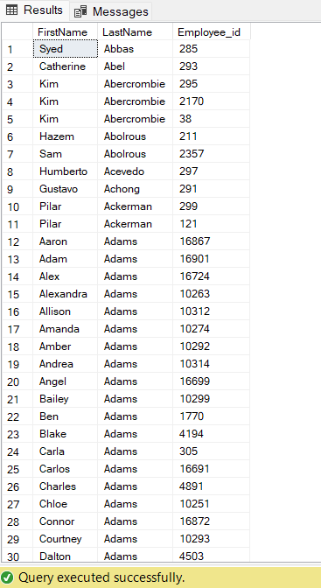
4.
USE AdventureWorks2019
GO
SELECT ProductID, ProductNumber,Name FROM Production.Product
WHERE SellStartDate IS NOT NULL AND ProductLine ='T'
ORDER BY Name ASC
Output:
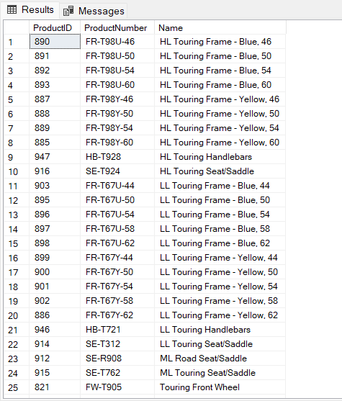
5.
USE AdventureWorks2019
GO
SELECT SalesOrderID, CustomerID, OrderDate, SubTotal, (TaxAmt/SubTotal)*100 AS tax_percent FROM Sales.SalesOrderHeader
ORDER BY SubTotal ASC
Output:
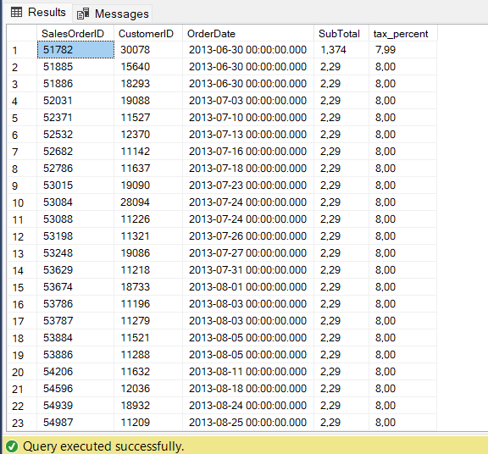
6.
USE AdventureWorks2019
GO
SELECT DISTINCT JobTitle FROM HumanResources.Employee
ORDER BY JobTitle ASC
Output:
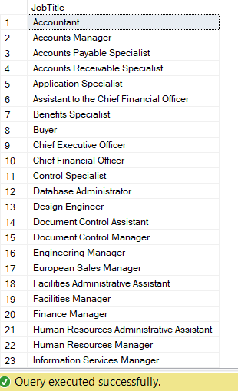
7.
USE AdventureWorks2019
GO
SELECT CustomerID, SUM(Freight) AS total_freight FROM Sales.SalesOrderHeader
GROUP BY CustomerID
ORDER BY CustomerID ASC
Output:
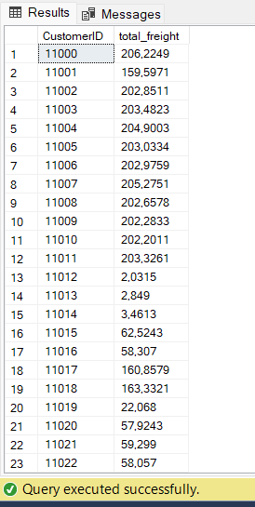
8.
USE AdventureWorks2019
GO
SELECT CustomerID,SalesPersonID, AVG(SubTotal) AS avg_subtotal, SUM(SubTotal) AS sum_subtotal FROM Sales.SalesOrderHeader
GROUP BY CustomerID, SalesPersonID
ORDER BY CustomerID DESC
Output:
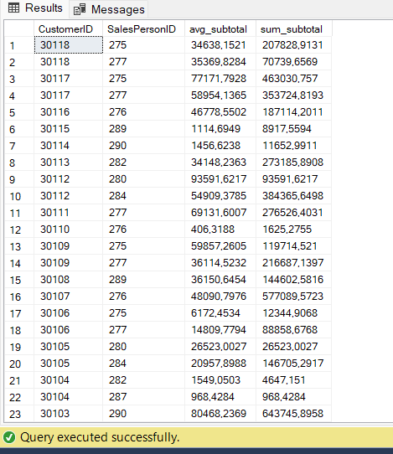
9.
USE AdventureWorks2019
GO
SELECT ProductID, SUM(Quantity) AS total_quantity FROM Production.ProductInventory WHERE Shelf IN ('A','C','H')
GROUP BY ProductID HAVING SUM(Quantity) >500
ORDER BY ProductID ASC
Output:
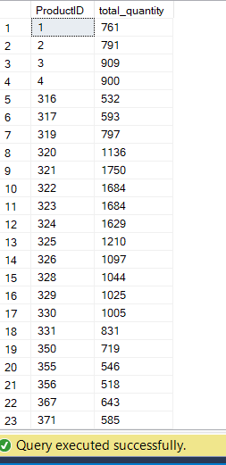
10.
USE AdventureWorks2019
GO
SELECT SUM(Quantity) *10 AS total_quantity FROM Production.ProductInventory
GROUP BY LocationID
Output:
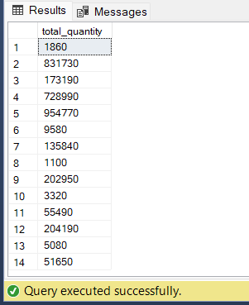
11.
USE AdventureWorks2019
GO
SELECT p.BusinessEntityID, p.FirstName, p.LastName, ph.PhoneNumber AS person_phone FROM Person.Person AS p
LEFT JOIN Person.PersonPhone AS ph ON p.BusinessEntityID = ph.BusinessEntityID
WHERE p.LastName LIKE 'L%'
ORDER BY p.LastName ASC, p.FirstName ASC
Output:
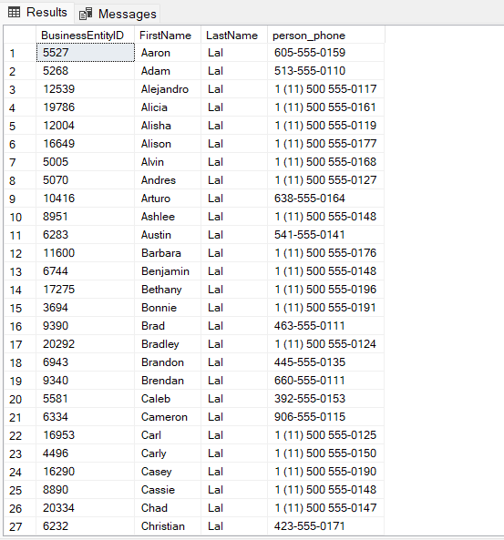
12.
USE AdventureWorks2019
GO
SELECT SalesPersonID, CustomerID,SUM(SubTotal) AS sum_subtotal FROM Sales.SalesOrderHeader
WHERE SalesPersonID IS NOT NULL
GROUP BY ROLLUP (SalesPersonID, CustomerID)
ORDER BY SalesPersonID, CustomerID
Output:
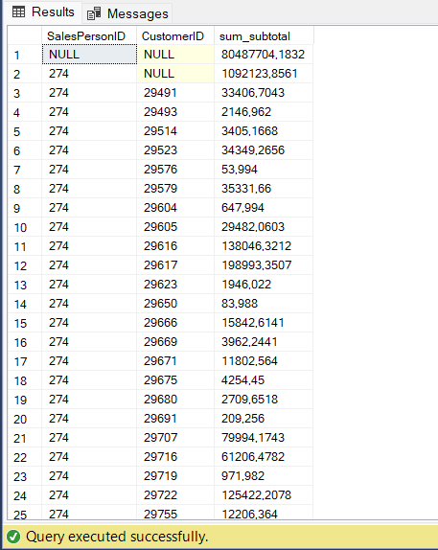
13.
USE AdventureWorks2019
GO
SELECT LocationID, Shelf, SUM(Quantity) AS TotalQuantity FROM Production.ProductInventory
GROUP BY ROLLUP (LocationID, Shelf)
ORDER BY LocationID, Shelf
Output:
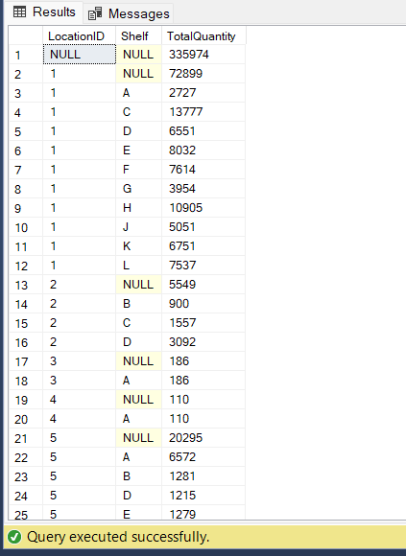
14.
USE AdventureWorks2019
GO
SELECT LocationID, Shelf, SUM(Quantity) AS TotalQuantity FROM Production.ProductInventory
GROUP BY ROLLUP (LocationID, Shelf)
ORDER BY LocationID, Shelf
Output:
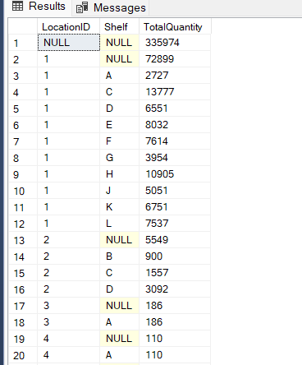
15.
USE AdventureWorks2019
GO
SELECT LocationID, SUM(Quantity) AS TotalQuantity FROM Production.ProductInventory
GROUP BY ROLLUP (LocationID)
ORDER BY LocationID
Output:
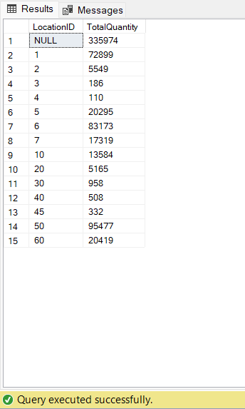
16.
USE AdventureWorks2019
GO
SELECT CITY, COUNT(*) AS noofemployees FROM Person.Address
GROUP BY City
ORDER BY City ASC
Output:
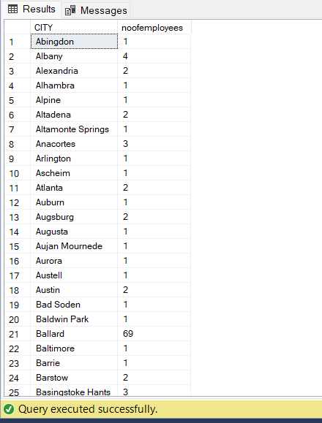
17.
USE AdventureWorks2019
GO
SELECT YEAR(OrderDate) AS YearOfOrderDate, SUM(TotalDue) AS TotalDueOrder FROM Sales.SalesOrderHeader
GROUP BY YEAR(OrderDate)
ORDER BY YEAR(OrderDate) ASC
Output:
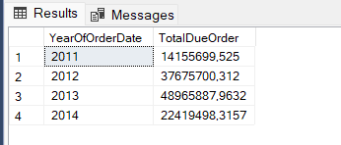
18.
USE AdventureWorks2019
GO
SELECT YEAR(OrderDate) AS YearOfOrderDate, SUM(TotalDue) AS TotalDueOrder FROM Sales.SalesOrderHeader
WHERE YEAR(OrderDate) <= 2016
GROUP BY YEAR(OrderDate)
ORDER BY YEAR(OrderDate) ASC
Output:
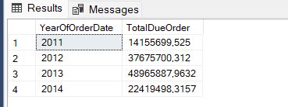
19.
USE AdventureWorks2019
GO
SELECT ContactTypeID, Name FROM Person.ContactType
WHERE Name LIKE '%Manager%'
ORDER BY ContactTypeID DESC
Output:
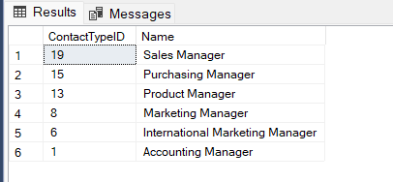
20.
USE AdventureWorks2019
GO
SELECT p.BusinessEntityID, p.LastName, p.FirstName FROM Person.Person AS p
JOIN Person.BusinessEntityContact AS bec ON p.BusinessEntityID = bec.PersonID
JOIN Person.ContactType AS ct ON bec.ContactTypeID = ct.ContactTypeID
WHERE ct.Name = 'Purchasing Manager'
ORDER BY p.LastName ASC, p.FirstName ASC
Output:
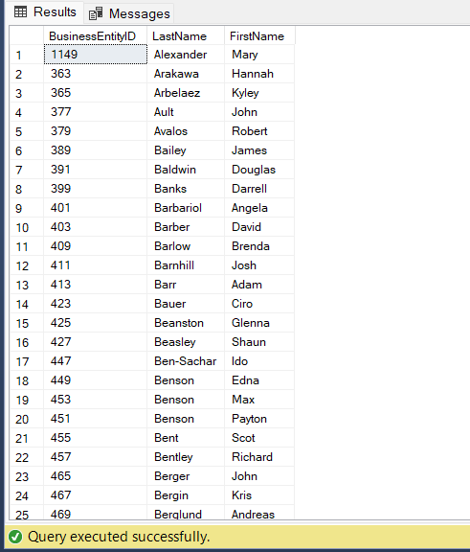
21.
USE AdventureWorks2019
GO
SELECT ROW_NUMBER() OVER (PARTITION BY a.PostalCode ORDER BY sp.SalesYTD DESC) AS RowNum, p.LastName, sp.SalesYTD, a.PostalCode FROM Sales.SalesPerson sp
INNER JOIN Person.Person p ON sp.BusinessEntityID = p.BusinessEntityID
INNER JOIN Person.Address a ON p.BusinessEntityID = a.AddressID
INNER JOIN Sales.SalesTerritory st ON sp.TerritoryID = st.TerritoryID
WHERE sp.SalesYTD <> 0 AND a.PostalCode IS NOT NULL
ORDER BY a.PostalCode ASC, sp.SalesYTD DESC
Output:
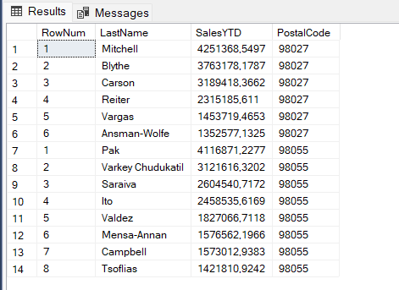

22.
USE AdventureWorks2019
GO
SELECT ct.ContactTypeID, ct.Name AS ContactTypeName, COUNT(*) AS NoContacts FROM Person.ContactType AS ct
JOIN Person.BusinessEntityContact AS bec ON ct.ContactTypeID = bec.ContactTypeID
GROUP BY ct.ContactTypeID, ct.Name HAVING COUNT(*) >= 100
ORDER BY NoContacts DESC
Output:
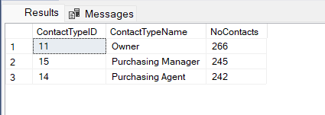

23.
USE AdventureWorks2019
GO
SELECT CONVERT(date, eph.RateChangeDate) AS fromdate, p.LastName + ', ' + p.FirstName + COALESCE(' ' + LEFT(p.MiddleName, 1), '') AS nameinfull,
CAST(eph.Rate * 40 AS decimal(18,4)) AS salaryinaweek FROM HumanResources.EmployeePayHistory AS eph
INNER JOIN HumanResources.Employee AS e ON e.BusinessEntityID = eph.BusinessEntityID
INNER JOIN Person.Person AS p ON p.BusinessEntityID = e.BusinessEntityID
ORDER BY nameinfull ASC
Output:
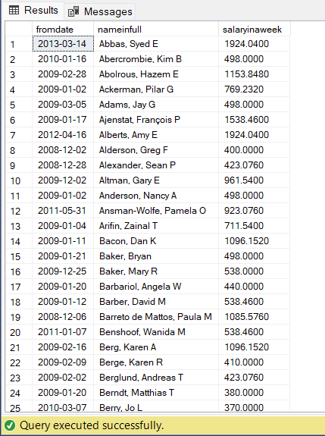

24.
USE AdventureWorks2019
GO
SELECT CONVERT(date, eph.RateChangeDate) AS fromdate, p.LastName + ', ' + p.FirstName + COALESCE(' ' + LEFT(p.MiddleName, 1), '') AS nameinfull,
CAST(eph.Rate * 40 AS decimal(18,4)) AS salaryinaweek FROM HumanResources.EmployeePayHistory AS eph
INNER JOIN HumanResources.Employee AS e ON e.BusinessEntityID = eph.BusinessEntityID
INNER JOIN Person.Person AS p ON p.BusinessEntityID = e.BusinessEntityID
INNER JOIN (SELECT BusinessEntityID, MAX(RateChangeDate) AS LatestChange FROM HumanResources.EmployeePayHistory
GROUP BY BusinessEntityID
) AS latest ON latest.BusinessEntityID = eph.BusinessEntityID AND latest.LatestChange = eph.RateChangeDate
ORDER BY nameinfull ASC
Output:
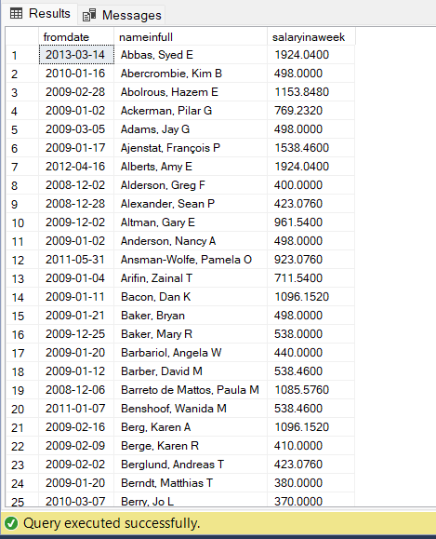

25.
USE AdventureWorks2019
GO
SELECT d.SalesOrderID, d.ProductID, d.OrderQty, agg.TotalQty AS [Total Quantity], agg.AvgQty AS [Avg Quantity], agg.OrderCount AS [No of Orders],
agg.MinQty AS [Min Quantity], agg.MaxQty AS [Max Quantity] FROM Sales.SalesOrderDetail AS d
CROSS JOIN (SELECT SUM(d2.OrderQty) AS TotalQty, AVG(CAST(d2.OrderQty AS decimal(18,6))) AS AvgQty, COUNT(*) AS OrderCount, MIN(d2.OrderQty) AS MinQty,
MAX(d2.OrderQty) AS MaxQty FROM Sales.SalesOrderDetail AS d2
WHERE d2.SalesOrderID IN (43659, 43664)) AS agg
WHERE d.SalesOrderID IN (43659, 43664)
ORDER BY d.SalesOrderID, d.ProductID
Output:
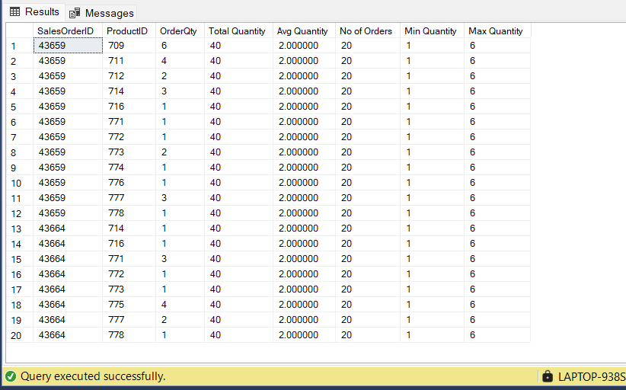
26
USE AdventureWorks2019
GO
SELECT SalesOrderID AS OrderNumber, ProductID, OrderQty AS Quantity, SUM(OrderQty) OVER (ORDER BY SalesOrderID, ProductID) AS Total,
AVG(OrderQty) OVER (ORDER BY SalesOrderID, ProductID) AS Avg, COUNT(OrderQty) OVER (ORDER BY SalesOrderID, ProductID) AS Count FROM Sales.SalesOrderDetail
WHERE SalesOrderID IN (43659, 43664) AND ProductID LIKE '71%'
ORDER BY SalesOrderID, ProductID
Output:
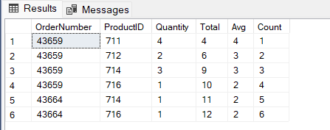
27
USE AdventureWorks2019
GO
SELECT SalesOrderID, SUM(OrderQty * UnitPrice) AS TotalCost FROM Sales.SalesOrderDetail
GROUP BY SalesOrderID HAVING SUM(OrderQty * UnitPrice) > 100000
Output:
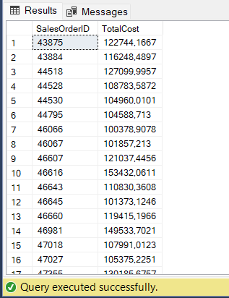
28
USE AdventureWorks2019
GO
SELECT ProductID, Name FROM Production.Product
WHERE Name LIKE 'Lock Washer%'
ORDER BY ProductID ASC
Output:
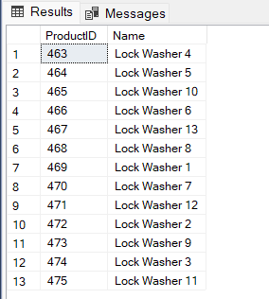
29
USE AdventureWorks2019
GO
SELECT ProductID, Name, Color FROM Production.Product
ORDER BY ListPrice
Output:
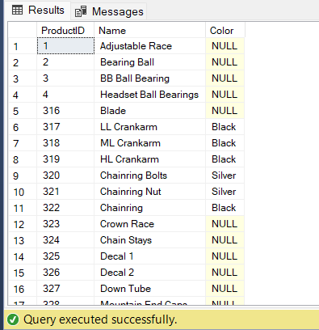
30
USE AdventureWorks2019
GO
SELECT BusinessEntityID, JobTitle, HireDate FROM HumanResources.Employee
ORDER BY YEAR(HireDate)
Output:
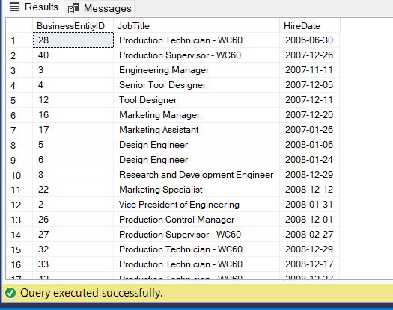
31
USE AdventureWorks2019
GO
SELECT LastName, FirstName FROM Person.Person
WHERE LastName LIKE 'R%'
ORDER BY FirstName ASC, LastName DESC
Output:
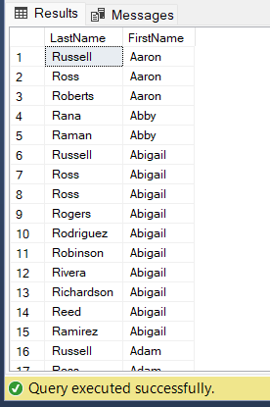
32
USE AdventureWorks2019
GO
SELECT BusinessEntityID, SalariedFlag FROM HumanResources.Employee
ORDER BY
CASE WHEN SalariedFlag = 1 THEN 0 ELSE 1 END,
CASE WHEN SalariedFlag = 1 THEN BusinessEntityID END DESC,
CASE WHEN SalariedFlag = 0 THEN BusinessEntityID END ASC
Output:
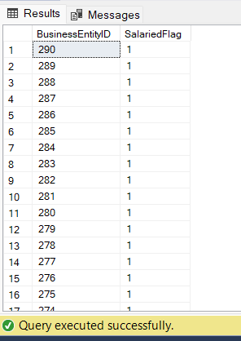
33
USE AdventureWorks2019
GO
SELECT sp.BusinessEntityID AS businessentityid, p.LastName AS lastname, st.Name AS territoryname, cr.Name AS countryregionname FROM Sales.SalesPerson AS sp
JOIN Person.Person AS p ON p.BusinessEntityID = sp.BusinessEntityID
LEFT JOIN Sales.SalesTerritory AS st ON st.TerritoryID = sp.TerritoryID
LEFT JOIN Person.CountryRegion AS cr ON cr.CountryRegionCode = st.CountryRegionCode
ORDER BY
CASE WHEN cr.Name = 'United States' THEN 1 ELSE 0 END,
CASE WHEN cr.Name = 'United States' THEN st.Name END ASC,
CASE WHEN cr.Name <> 'United States' THEN cr.Name END ASC
Output:
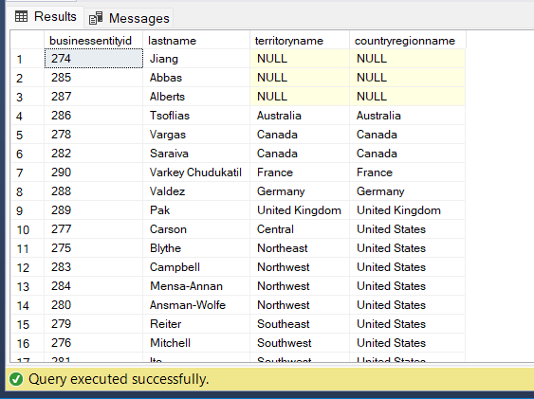
34
USE AdventureWorks2019
GO
SELECT p.FirstName, p.LastName, ROW_NUMBER() OVER (ORDER BY a.PostalCode) AS [Row Number], RANK() OVER (ORDER BY a.PostalCode) AS [Rank],
DENSE_RANK() OVER (ORDER BY a.PostalCode) AS [Dense Rank], NTILE(4) OVER (ORDER BY a.PostalCode) AS Quartile, sp.SalesYTD, a.PostalCode
FROM Sales.SalesPerson AS sp
JOIN Person.Person AS p ON sp.BusinessEntityID = p.BusinessEntityID
JOIN Sales.SalesTerritory AS st ON sp.TerritoryID = st.TerritoryID
JOIN Person.BusinessEntityAddress AS bea ON p.BusinessEntityID = bea.BusinessEntityID
JOIN Person.Address AS a ON bea.AddressID = a.AddressID
WHERE sp.SalesYTD <> 0
ORDER BY a.PostalCode
Output:
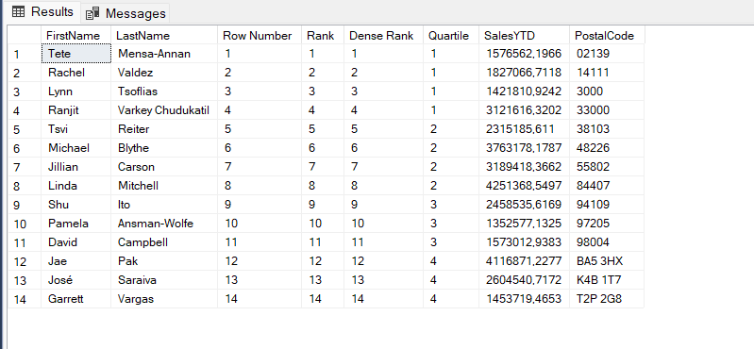
35
USE AdventureWorks2019
GO
SELECT DepartmentID, Name, GroupName FROM HumanResources.Department
ORDER BY DepartmentID
OFFSET 10 ROWS
Output:
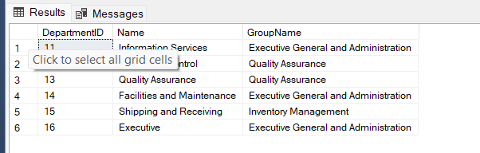
36
USE AdventureWorks2019
GO
SELECT DepartmentID, Name, GroupName FROM HumanResources.Department
ORDER BY DepartmentID
OFFSET 5 ROWS
FETCH NEXT 5 ROWS ONLY
Output:
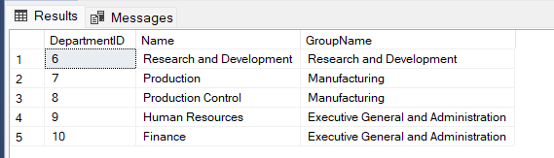
37
USE AdventureWorks2019
GO
SELECT Name, Color, ListPrice FROM Production.Product
WHERE Color IN ('Red', 'Blue')
ORDER BY ListPrice
Output:
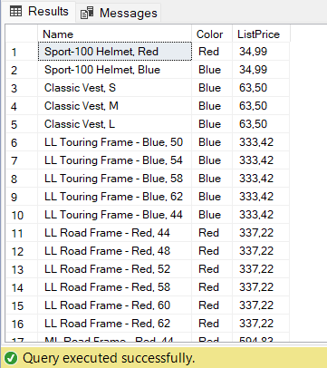
38
USE AdventureWorks2019
GO
SELECT p.Name AS ProductName, sod.SalesOrderID FROM Production.Product AS p
FULL OUTER JOIN Sales.SalesOrderDetail AS sod ON p.ProductID = sod.ProductID
ORDER BY p.Name
Output:
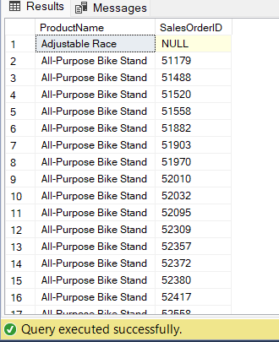
39
USE AdventureWorks2019
GO
SELECT p.Name, soh.SalesOrderID FROM Production.Product AS p
LEFT JOIN Sales.SalesOrderDetail AS sod ON p.ProductID = sod.ProductID
LEFT JOIN Sales.SalesOrderHeader AS soh ON sod.SalesOrderID = soh.SalesOrderID
ORDER BY p.Name
Output:
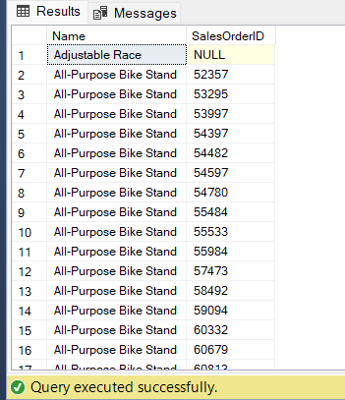
40
USE AdventureWorks2019
GO
SELECT p.Name, soh.SalesOrderID FROM Production.Product AS p
JOIN Sales.SalesOrderDetail AS sod ON sod.ProductID = p.ProductID
JOIN Sales.SalesOrderHeader AS soh ON soh.SalesOrderID = sod.SalesOrderID
ORDER BY p.Name ASC
Output:
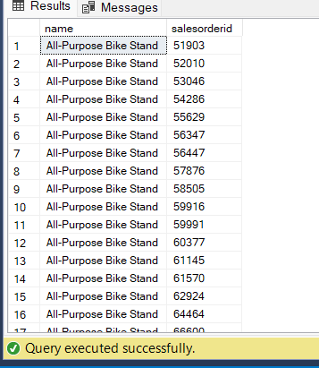
41
USE AdventureWorks2019
GO
SELECT st.Name AS Territory, sp.BusinessEntityID FROM Sales.SalesPerson AS sp
LEFT JOIN Sales.SalesTerritory AS st ON sp.TerritoryID = st.TerritoryID
Output:
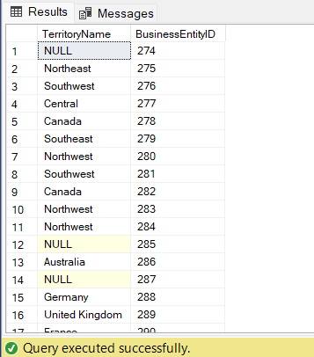
42

